***CELEBAL SUMMER INTERNSHIP***

**Assignment- Linux/Git**

**Submitted by: Hemansh Sankhla**

**--------------------------------------------------------------------------------------------------------------------------**

* **Create a file, assign permissions (read, write, execute) to different user categories (owner, group, others), and practice changing permissions using chmod.**

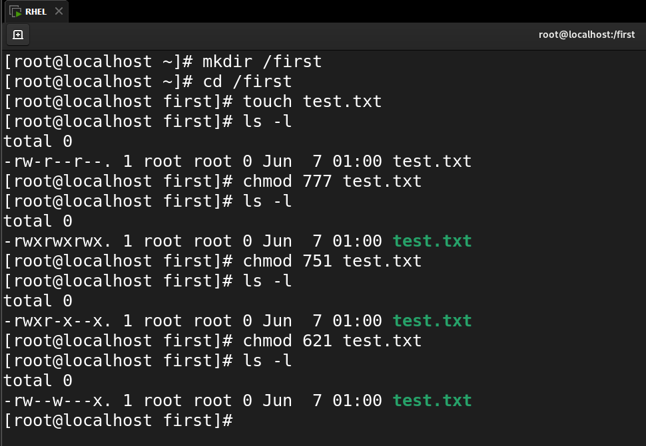

**--------------------------------------------------------------------------------------------------------------------------**

* **Execute basic Linux commands (e.g., ls, cd, mkdir, rm, touch) to manipulate files and directories, with an emphasis on understanding their usage**.

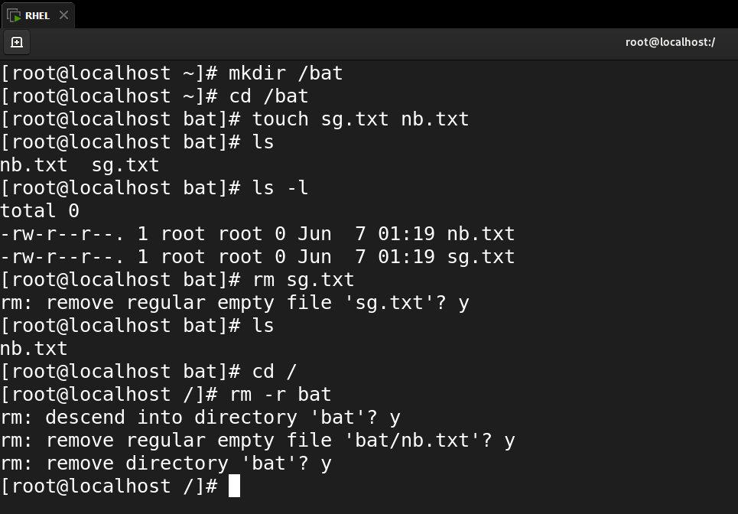

**--------------------------------------------------------------------------------------------------------------------------**

* **Using the terminal, practice navigating through directories, listing file contents, and moving files to different locations.**

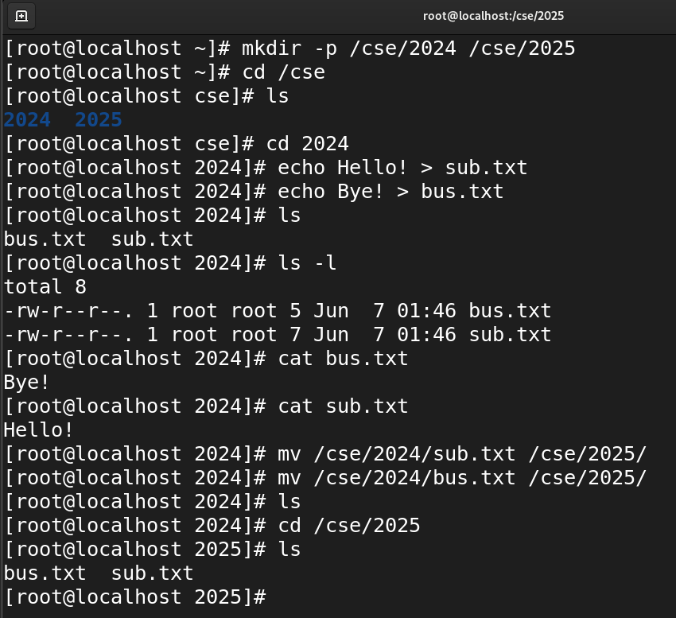

**--------------------------------------------------------------------------------------------------------------------------**

* **Create a new user and group, set their permissions, and explore user management commands like useradd, usermod, and userdel.**

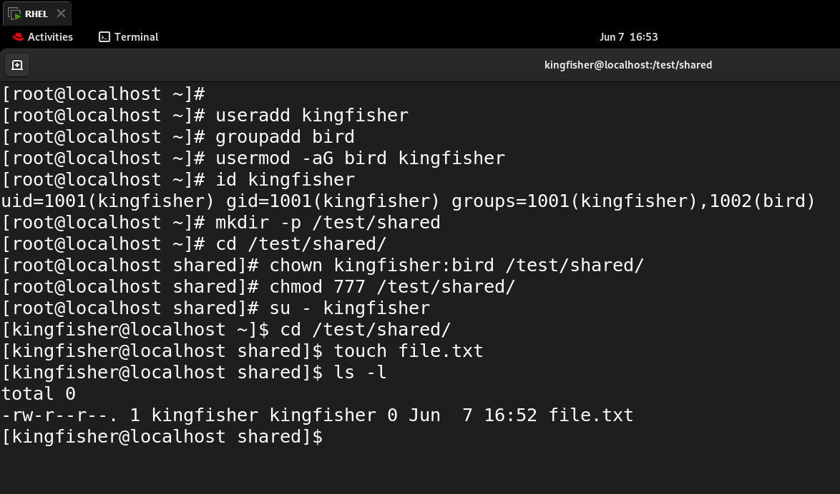

**--------------------------------------------------------------------------------------------------------------------------**

* **Practice more linux commands**

1. ping and translate command

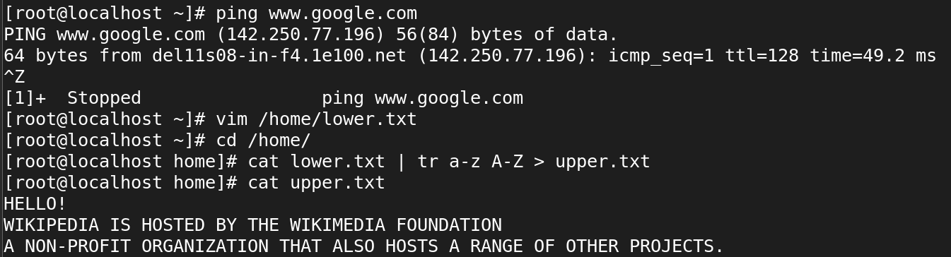

1. grep command

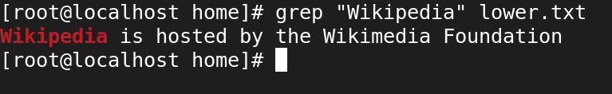

1. wget command

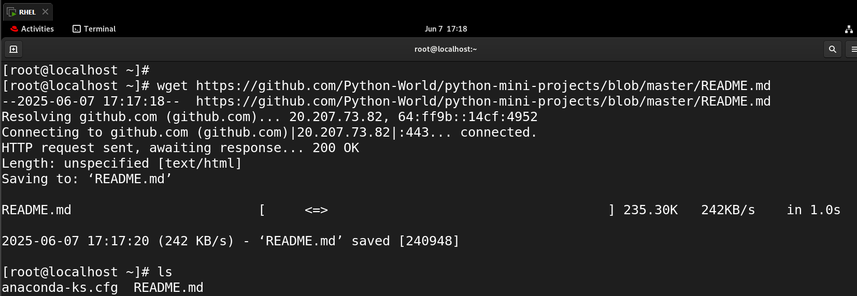

1. tar command

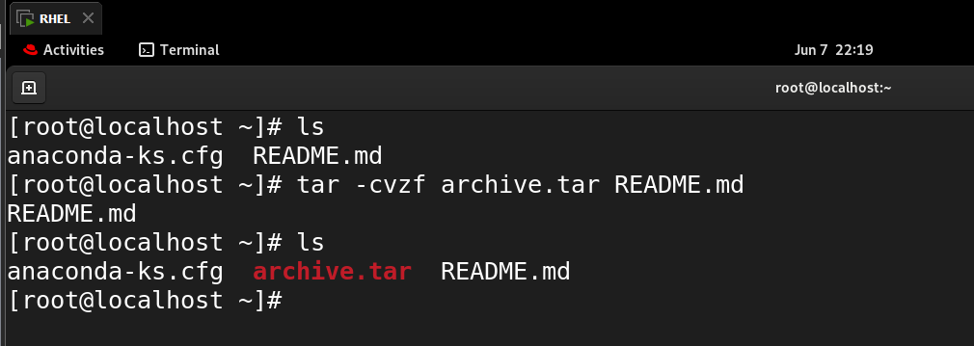

**--------------------------------------------------------------------------------------------------------------------------**

* **Introduction to version control and Git basics, Git installation and configuration, Basic Git commands (init, add, commit, push, pull)**

1. Git Installation

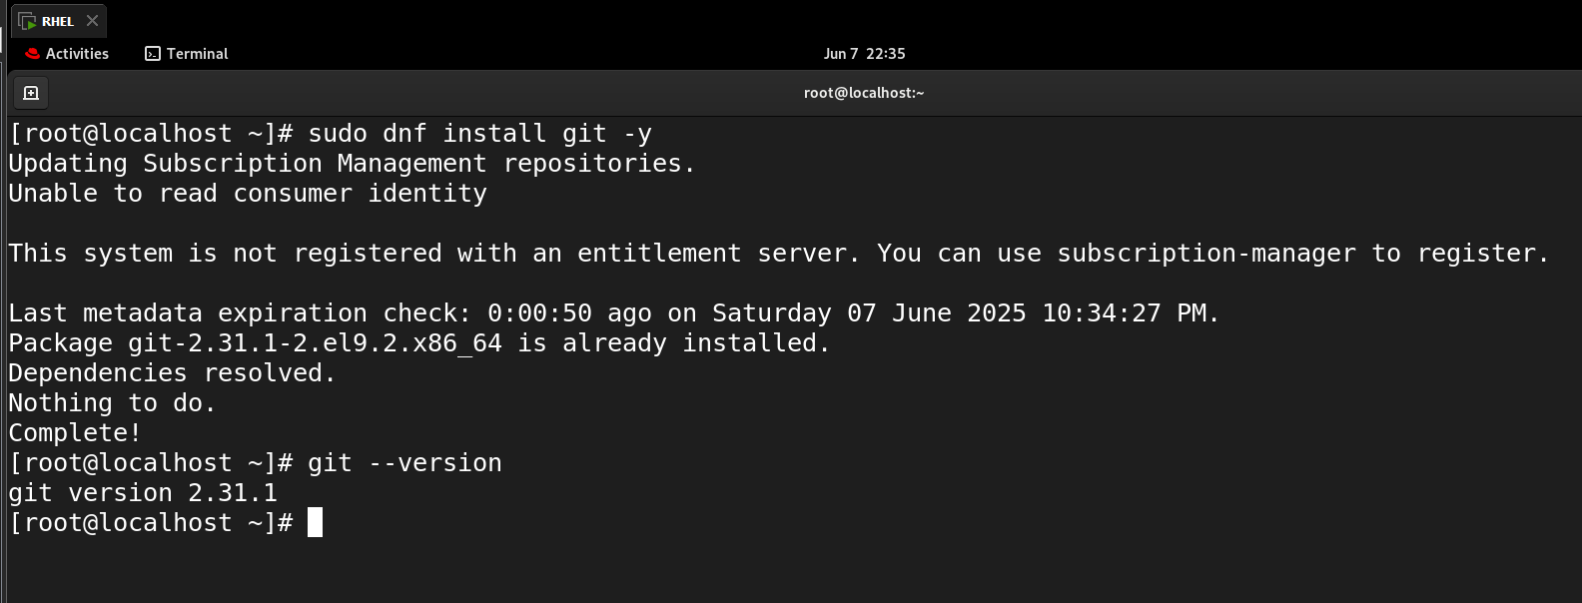

1. Git Configuration

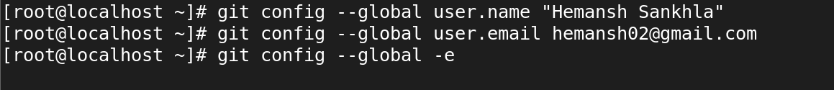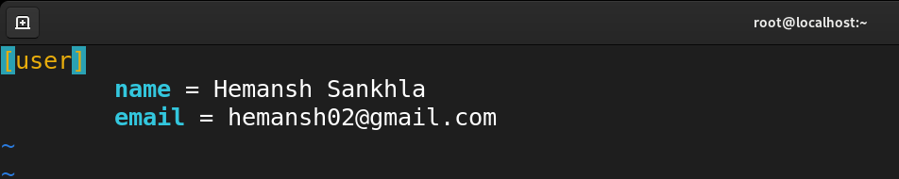

1. Initializing Git Repository

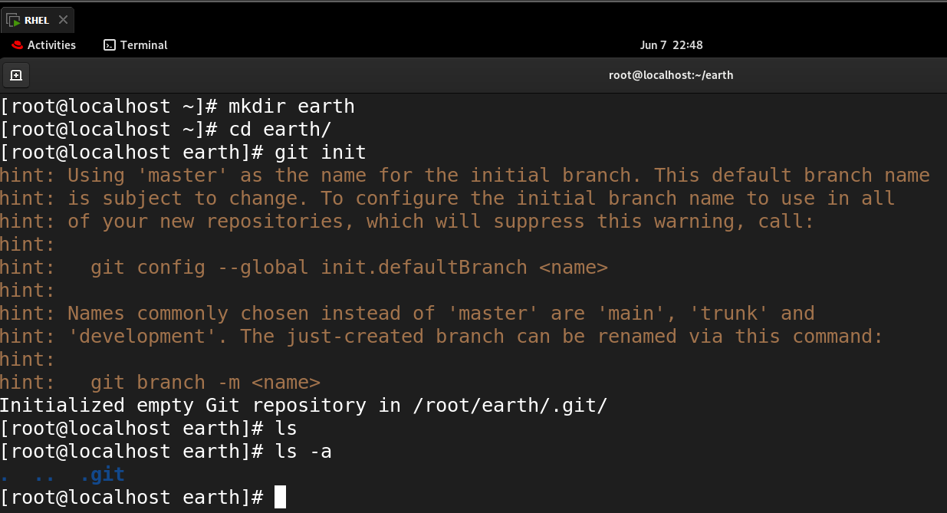

1. Creating files, adding them, and checking the status

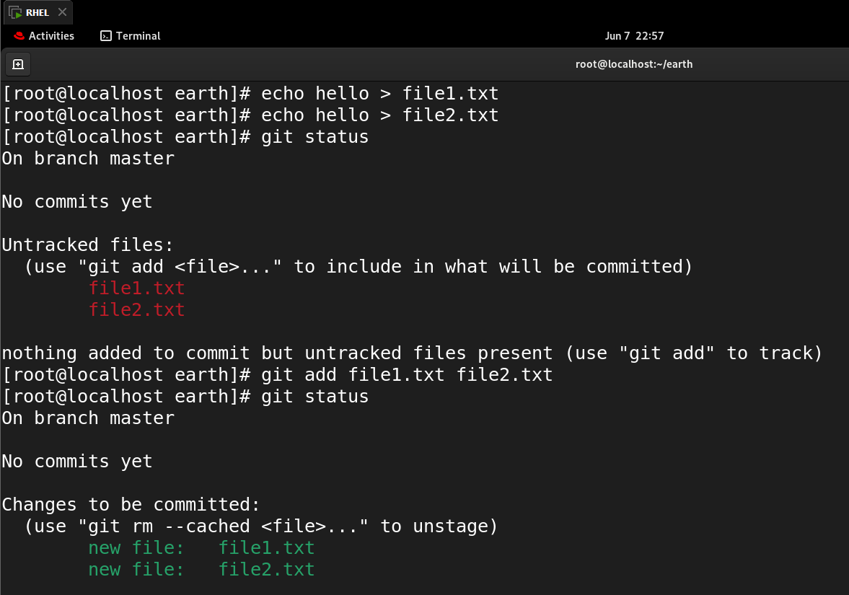

1. Commit the files, Create main branch, and Add remote origin

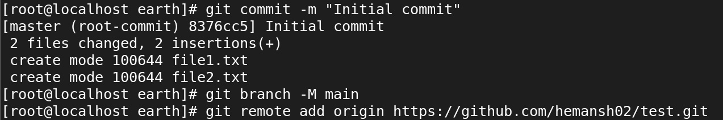

1. Pull the remote changes, then push.

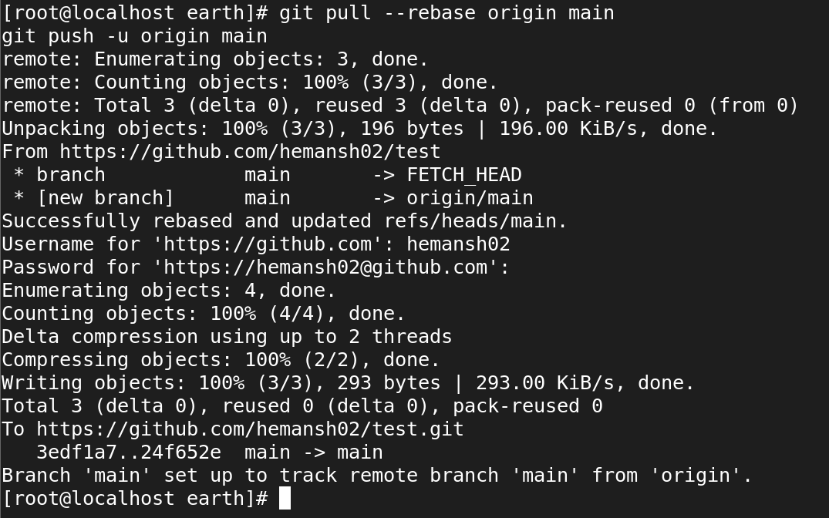

1. Finalized results in the github repo (remote branch)

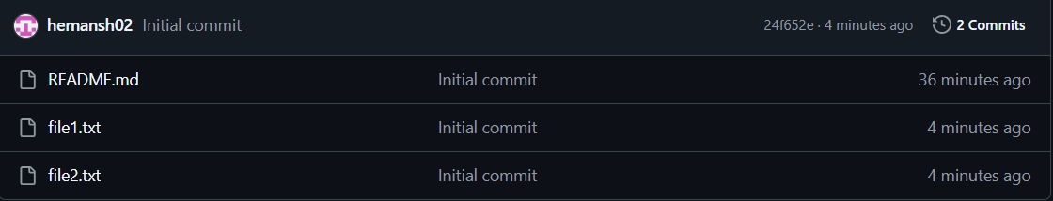

**--------------------------------------------------------------------------------------------------------------------------**

* **Setup a remote repository in Local, add a file and commit or save the changes and push to master branch**

1. Create a local bare remote repo

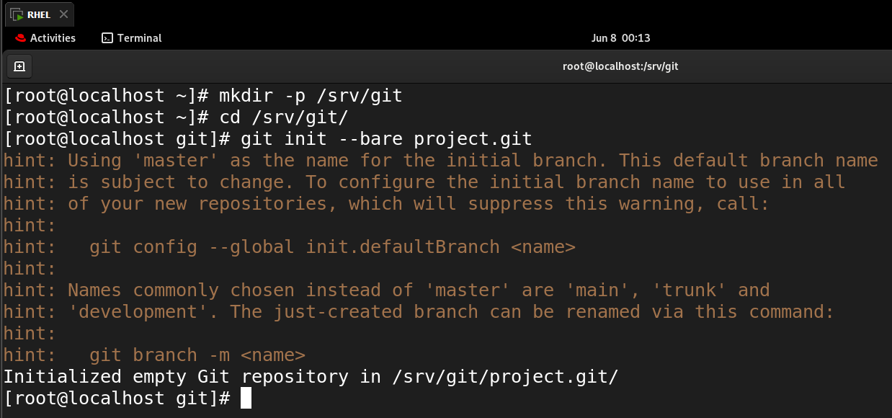

1. Create a working project and link the local remote

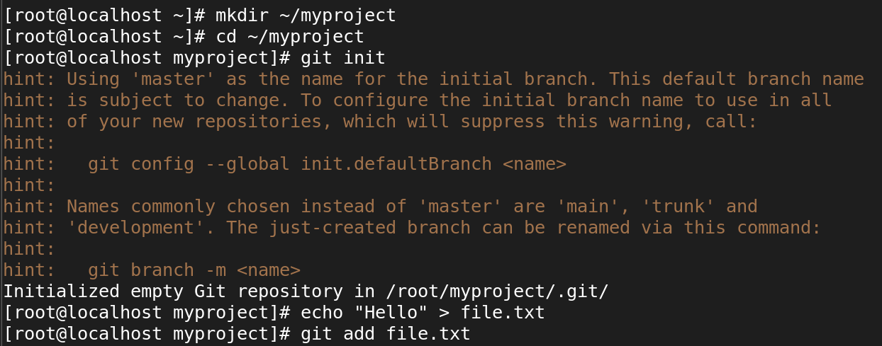

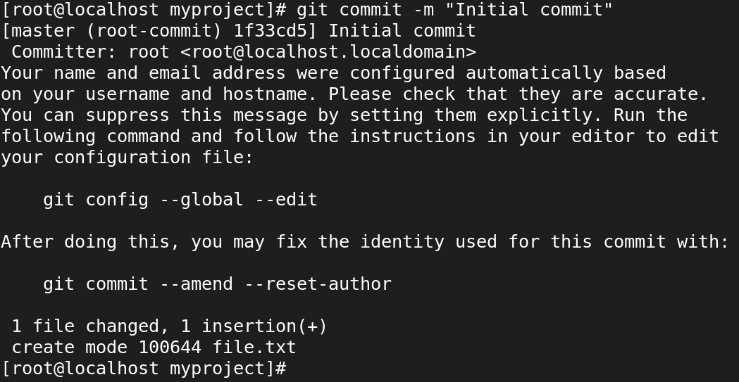

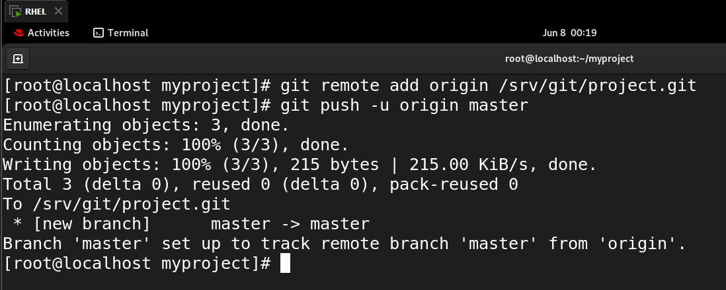

1. Check the remote origin, current branch, and file.

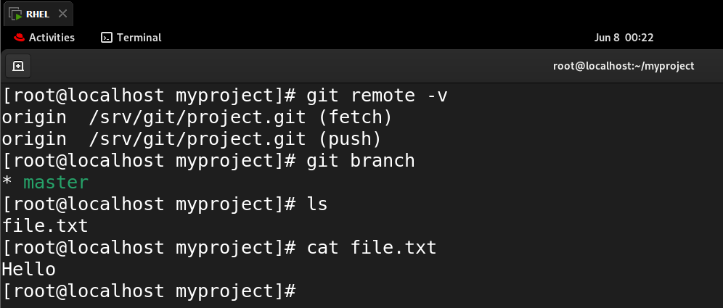

**--------------------------------------------------------------------------------------------------------------------------**

* **Merge types, Create a new branch then commit and push the changes to new branch and merge it with the master branch using pull request.**

1. Create a New Branch, Add a File, and Commit.

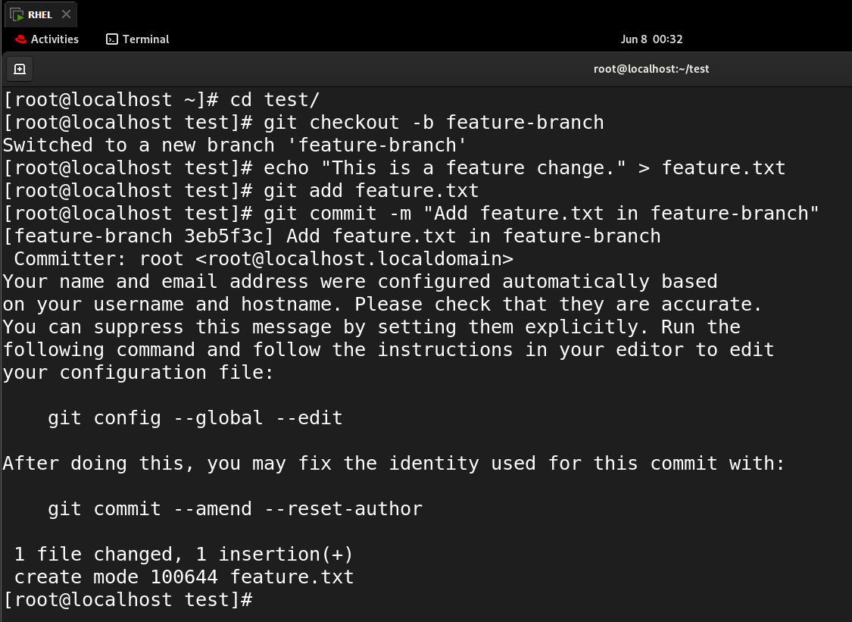

1. Push the Branch to Github

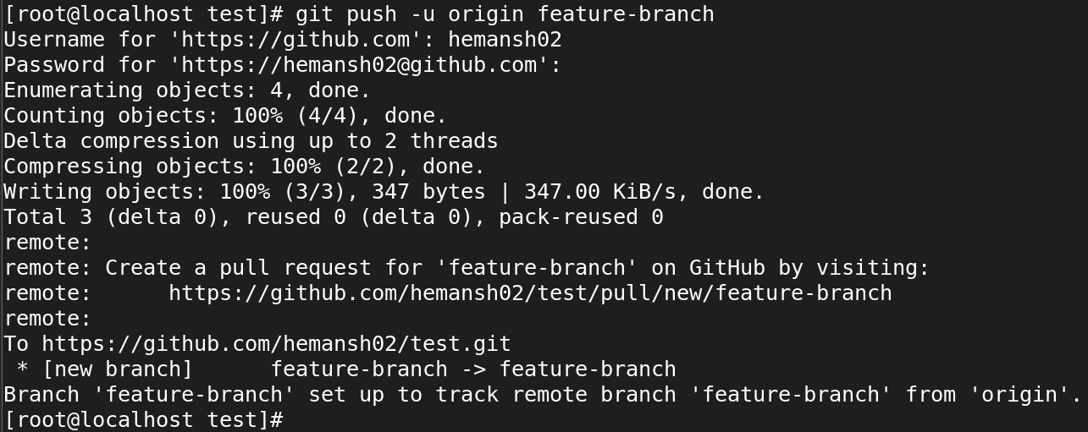

1. In Github Create Pull Request

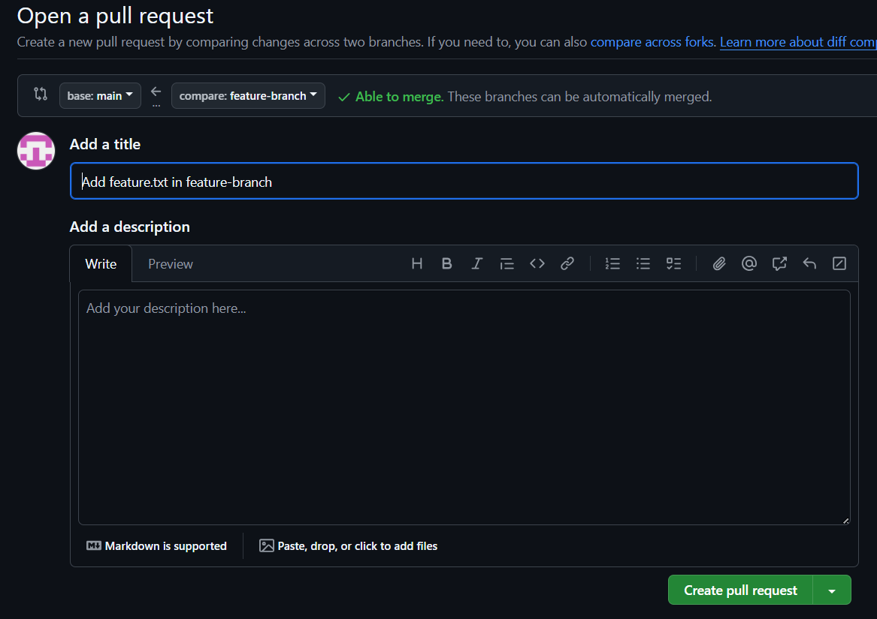

1. Merge the Pull Request

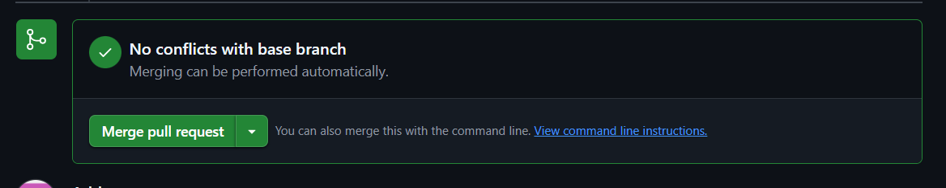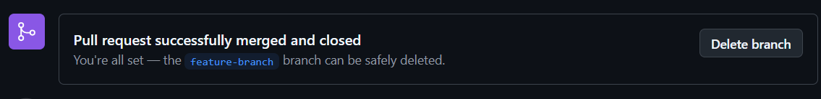

1. Update Local main Branch

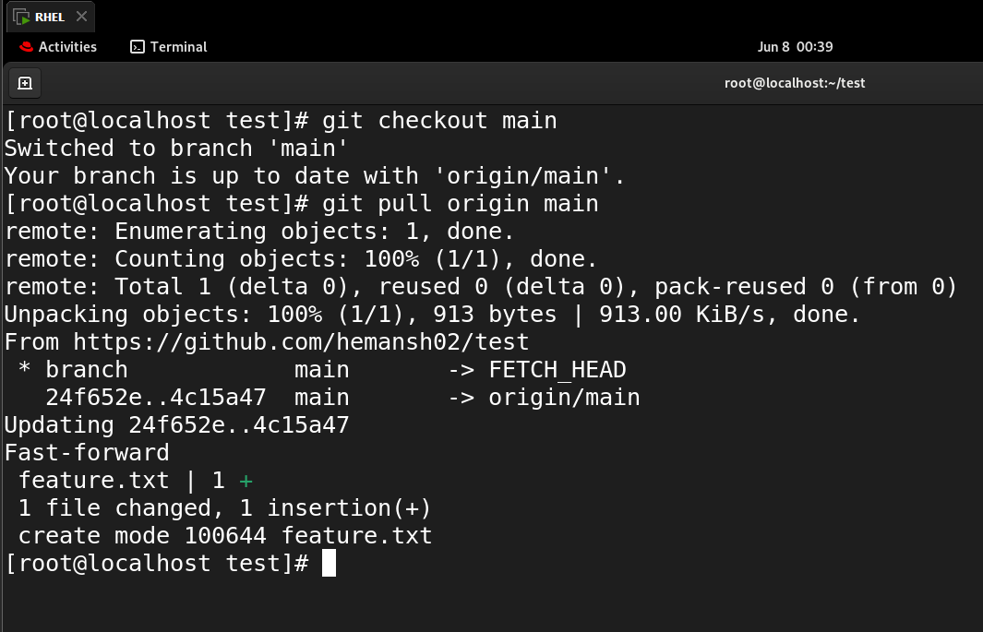

**--------------------------------------------------------------------------------------------------------------------------**

* **Undo the last commit or remove the last created file from remote repo using CLI**

1. Undo the last commit

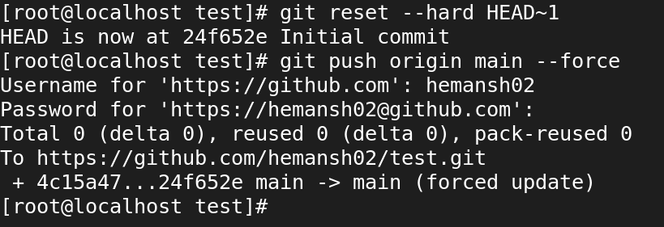

1. Verify in Github repo

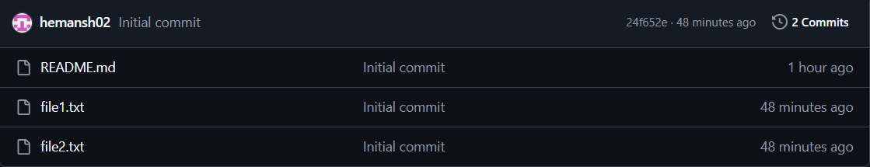

**--------------------------------------------------------------------------------------------------------------------------**

* **Branching and merging in Git, Resolve a merge conflicts, and Practice More git commands**

1. Initialize a Git repo, and Create a file on main

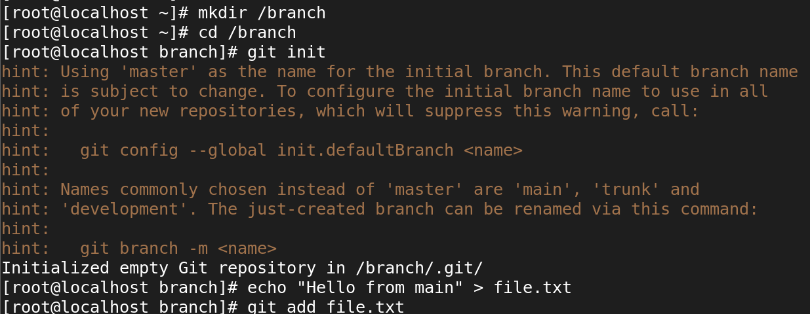

1. Commit the files

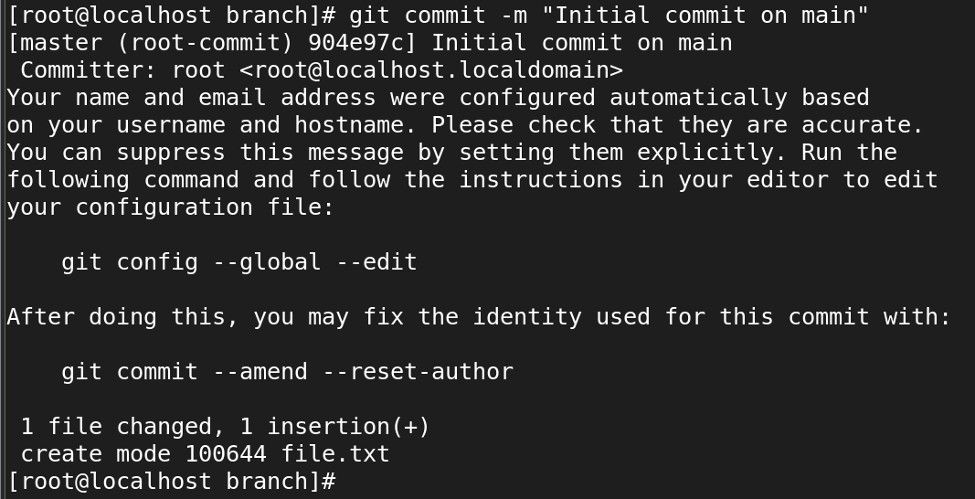

1. Create a new branch and made changes

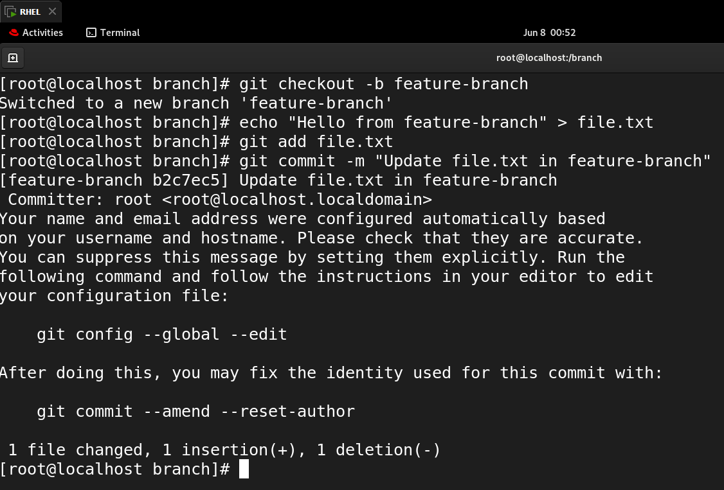

1. Switch back to main and made conflicting change

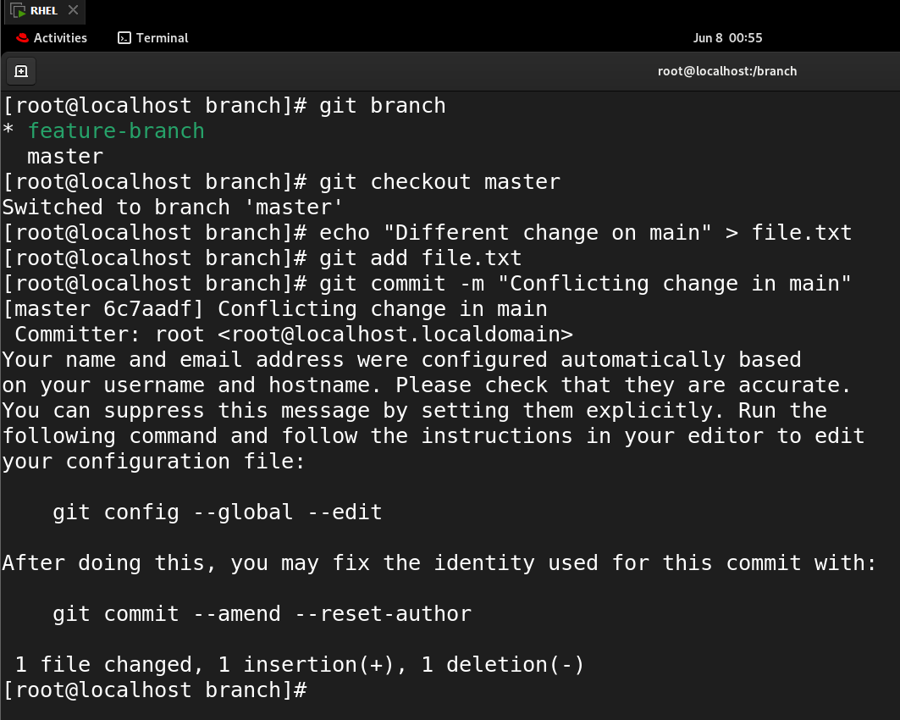

1. Try merging the feature-branch into main which gives merge conflict

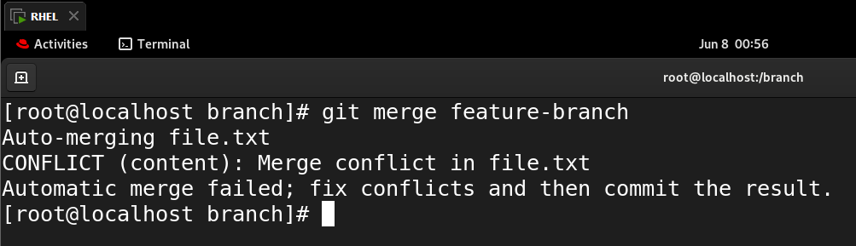

1. Resolve the conflict, open file.txt and rewrite it.

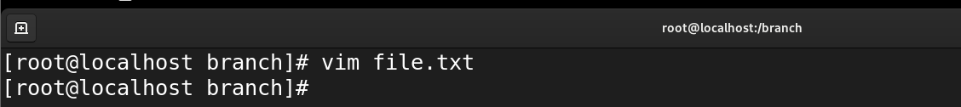

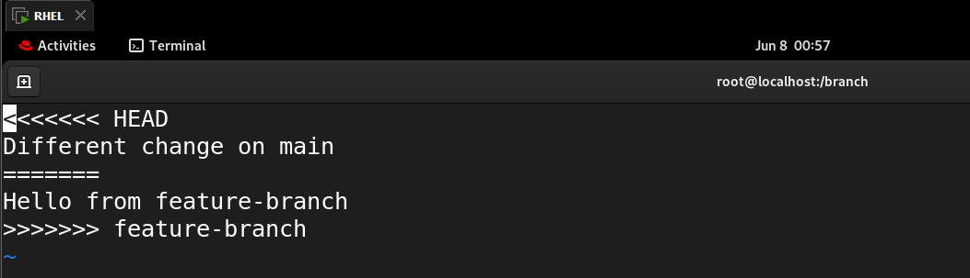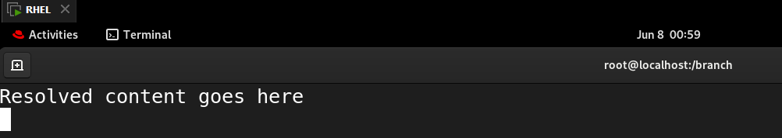

1. Resolved conflict and now commit the merge

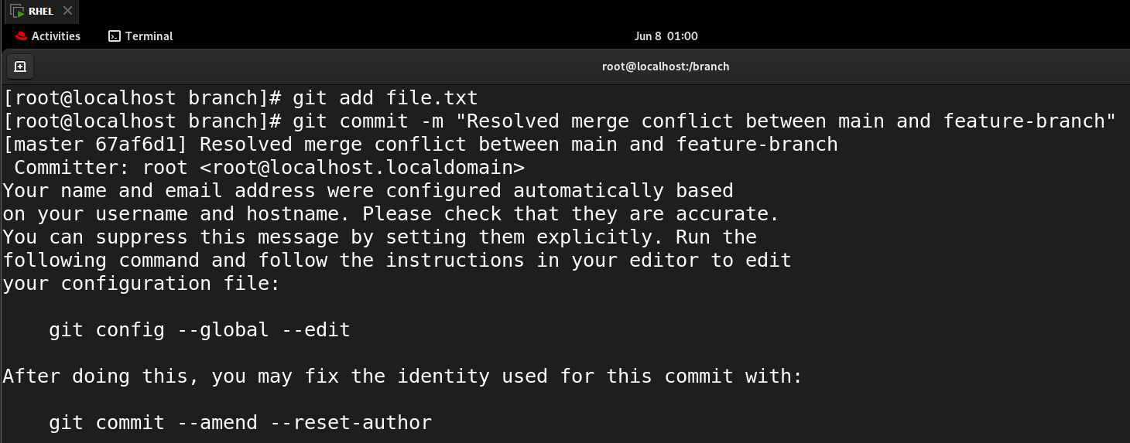

**--------------------------------------------------------------------------------------------------------------------------**

**THANK YOU!**